PWA video 20 conditional fallbacks

<https://www.youtube.com/watch?v=K9NXQZxKMko>

Don’t return the fallback page for an image or css request with a conditional statement. Do this in the fetch event too

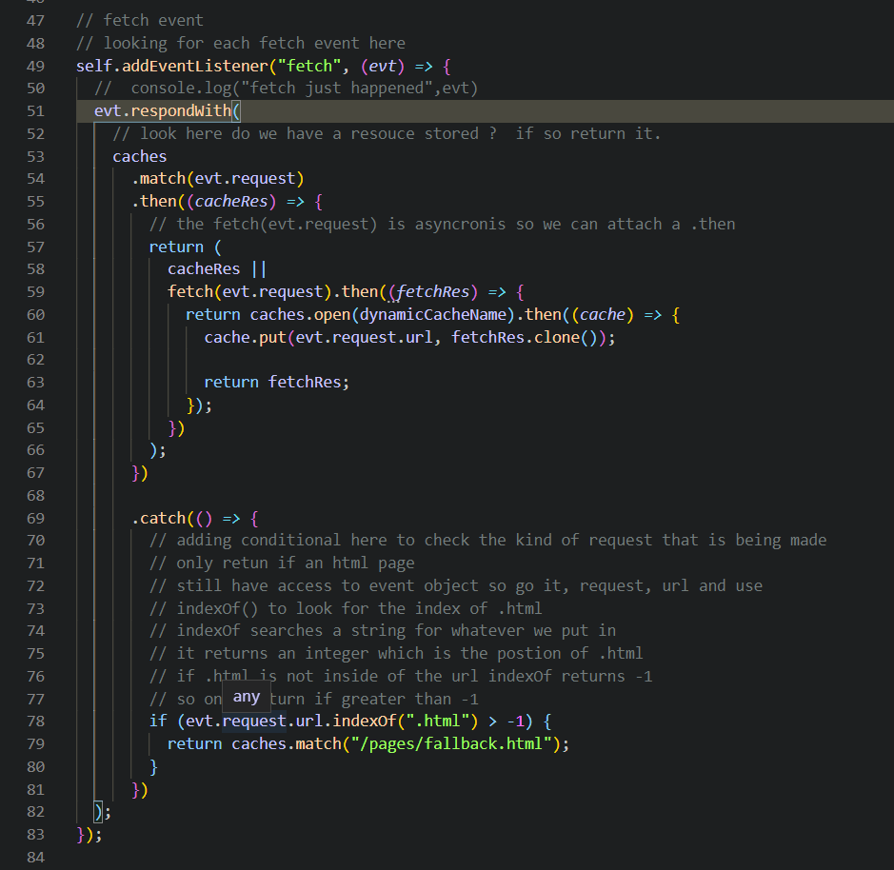

Could also do this for other things like .png

There are other approaches to manage cache and off line than using service worker.

Lin to article about the different strategies <https://web.dev/offline-cookbook/>